* **Menu driven 3:**

Q. write a menu driven program in which you have to enter a string into file, display contents ,count total no of vowels.?

**#include<fstream.h>**

**#include<conio.h>**

**#include<stdio.h>**

**void main()**

**{**

**clrscr();**

**void enterfile();**

**void displayfile();**

**void countvowels();**

**int c;**

**do**

**{**

**cout<<"\n main menu"<<endl;**

**cout<<"\n1.add a string"<<endl;**

**cout<<"\n2.display that string"<<endl;**

**cout<<"\n3.count total no of vowel"<<endl;**

**cout<<"\n4.exit"<<endl;**

**cout<<"enter your selection"<<" ";**

**cin>>c;**

**switch(c)**

**{**

**case 1:enterfile();**

**break;**

**case 2:displayfile();**

**break;**

**case 3:countvowels();**

**break;**

**}**

**}while(c!=4);**

**getche();**

**}**

**void enterfile()**

**{**

**char str[20];**

**int i;**

**ofstream afile("vowel.txt");**

**cout<<"enter your string";**

**gets(str);**

**for(i=0;str[i]!='\0';i++)**

**{**

**afile.put(str[i]);**

**}**

**afile.close();**

**getche();**

**}**

**void displayfile()**

**{**

**char ch;**

**ifstream bfile("vowel.txt");**

**while(bfile)**

**{**

**bfile.get(ch);**

**cout<<ch;**

**}**

**bfile.close();**

**getche();**

**}**

**void countvowels()**

**{**

**char ch1;**

**int j=0;**

**ifstream cfile("vowel.txt");**

**while(cfile)**

**{**

**cfile.get(ch1);**

**if(ch1=='a'||ch1=='e'||ch1=='o'||ch1=='i'||ch1=='u')**

**j++;**

**}**

**cout<<"Total vowels="<<j<<endl;**

**cfile.close();**

**getche();**

**}**

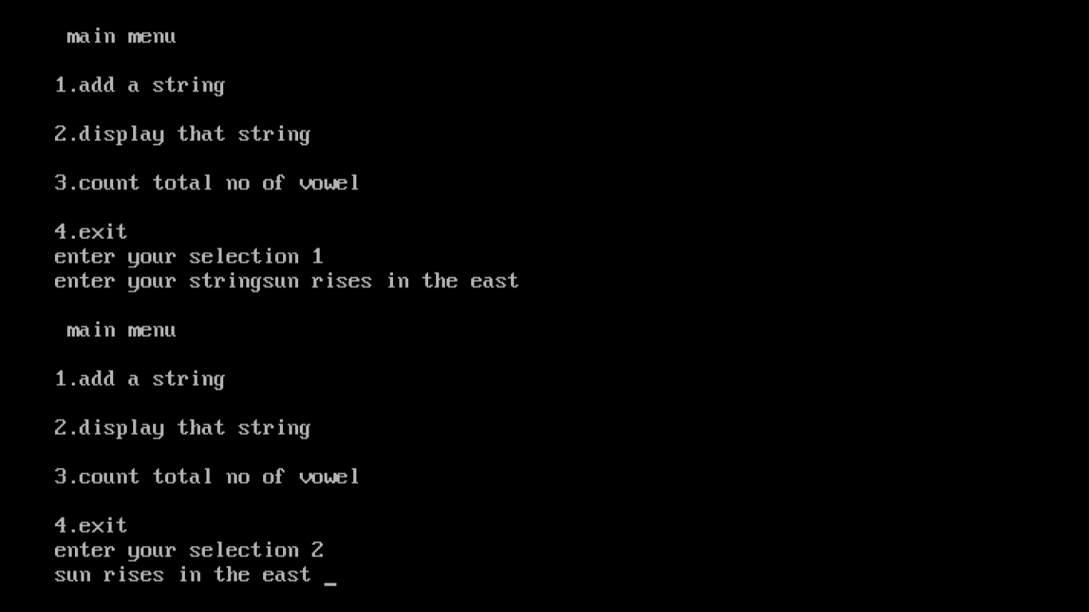

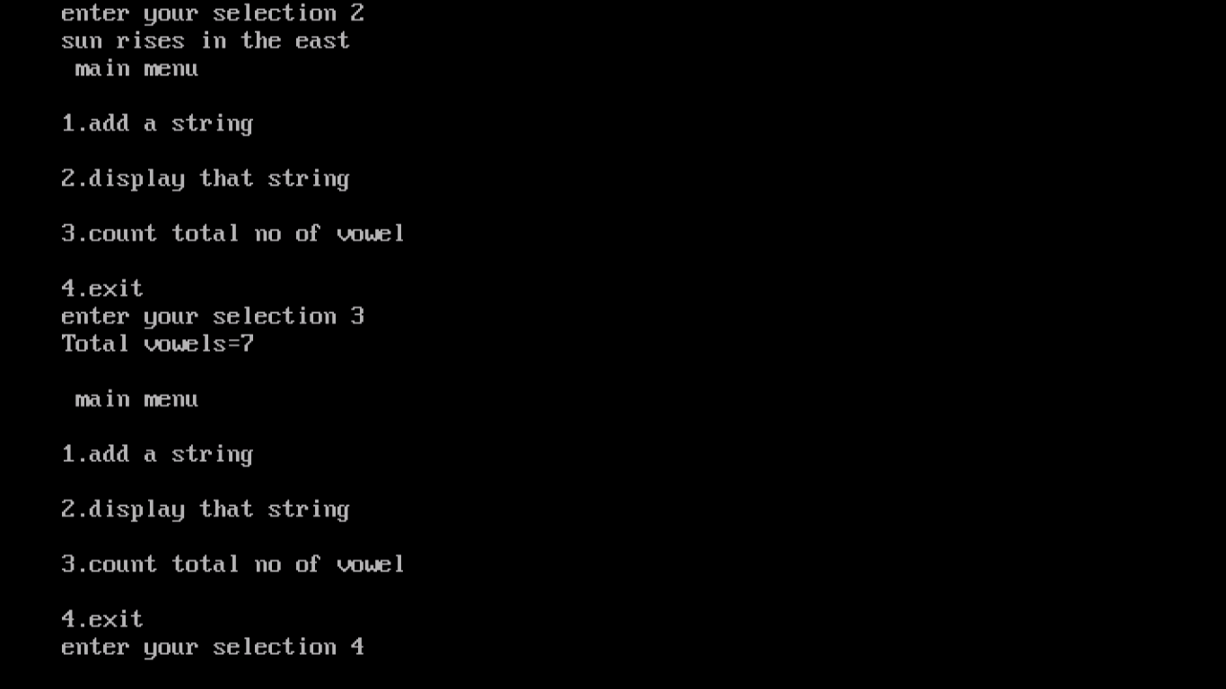

* **Menu driven 4:**

Q. write a menu driven program in which you have to enter n number of lines into the file, copy one file into

Another file and display the copied contents?

**#include<fstream.h>**

**#include<conio.h>**

**#include<stdio.h>**

**#include<string.h>**

**void main()**

**{**

**clrscr();**

**void enterfile();**

**void displayfile();**

**void copyfile();**

**int c;**

**do**

**{**

**cout<<"\n main menu"<<endl;**

**cout<<"\n 1.enter n number of lines"<<endl;**

**cout<<"\n 2.display those lines"<<endl;**

**cout<<"\n 3.copy the file from one to another file"<<endl;**

**cout<<"\n 4.exit"<<endl;**

**cout<<"\n enter your choice"<<" ";**

**cin>>c;**

**switch(c)**

**{**

**case 1:enterfile();**

**break;**

**case 2:displayfile();**

**break;**

**case 3:copyfile();**

**break;**

**}**

**}while(c!=4);**

**getche();**

**}**

**void enterfile()**

**{**

**char str[80];**

**int i;**

**int n;**

**cout<<"how many do you lines want to enter";**

**cin>>n;**

**ofstream afile("lines.txt");**

**for(i=0;i<n;i++)**

**{**

**cout<<"enter line"<<" ";**

**gets(str);**

**afile<<str<<endl;**

**}**

**afile.close();**

**getche();**

**}**

**void copyfile()**

**{**

**char str[80];**

**char str1[80];**

**ifstream bfile("lines.txt");**

**ofstream cfile("linescopy.txt");**

**while(bfile)**

**{**

**bfile.getline(str,79);**

**strcpy(str1,str);**

**}**

**cfile<<str1<<endl;**

**bfile.close();**

**cfile.close();**

**getche();**

**}**

**void displayfile()**

**{**

**char str1[80];**

**ifstream dfile("linescopy.txt");**

**while(dfile)**

**{**

**dfile.getline(str1,79);**

**}**

**cout<<str1<<" ";**

**dfile.close();**

**getche();**

**}**

